Department of Computer Science and Engineering
Assignment Questions
Course Code & Name : CSA0720- Computer Networks
Assignment Title: | Design and Performance Evaluation of a Smart Manufacturing Industrial Network
Course Outcome(s) – CO: | 1-Apply the functions of the OSI layer in enabling reliable data transmission across networks  2-Configure IP addressing schemes, subnetting, and basic routing techniques using a simulation tool, for efficient network design and topology  3-Analyze and compare the performance of core network protocols such as TCP, UDP, HTTP, and DNS under varying conditions  4-Design network topologies star, mesh, bus, and hybrid using networking devices, transmission media, and cabling standards  5-Measure network performance using key metrics with simulation tools
Bloom’s Taxonomy Level | L3 – Apply; L4 – Analyse, L5 – Evaluate
SDG Mapping (SDG 1-17) | SDG 11 – Sustainable Cities and Communities;  SDG 12 – Responsible Consumption and Production

Problem Statement : A manufacturing company is modernizing its production facility by connecting the Production Floor, Quality Inspection Unit, Warehouse, Administrative Office, IoT-enabled machines, and a Cloud Monitoring Centre. The existing network experiences communication delays, congestion during peak production hours, inefficient IP address allocation, and poor Quality of Service for time-sensitive applications such as machine monitoring, video surveillance, and real-time control.
As a network engineer, design and simulate a reliable industrial network that supports the above departments and devices. Select suitable network topologies, switches, routers, wireless devices, transmission media, and LAN/WAN connections. Divide the network into appropriate subnets/VLANs and develop an IPv4 addressing scheme. Implement and compare Distance Vector and Link State routing for inter-network communication using a suitable simulation tool. Demonstrate TCP and UDP communication and analyse their behaviour under different traffic conditions.
The network must provide congestion and traffic management with suitable QoS mechanisms so that critical industrial traffic receives higher priority than non-critical traffic. Configure appropriate application-layer services such as DNS, DHCP, HTTP/FTP and SNMP for network operation and monitoring. Incorporate IoT devices and cloud-based monitoring, and discuss SDN/network virtualization as an enhancement. Evaluate the proposed architecture using packet delivery ratio, throughput, end-to-end delay, packet loss and congestion, and recommend the most suitable network architecture for the company.
Industry-Based Tasks / Expected Analysis
1. Identify business and operational requirements and prepare a physical/logical network topology for the manufacturing facility.
2. Select network devices and transmission media and justify their suitability for industrial communication.
3. Create VLANs/subnets and an IPv4 addressing plan; demonstrate packet forwarding between the subnets.
4. Implement Distance Vector and Link State routing and compare routing behaviour and performance.
5. Configure TCP and UDP applications and analyse throughput, delay, packet loss and traffic/congestion behaviour.
6. Apply a suitable QoS/traffic-management strategy to prioritize time-sensitive machine-control and monitoring traffic.
7. Configure DNS, DHCP, HTTP/FTP and SNMP services and demonstrate their role in network operation and monitoring.
8. Add IoT/cloud-monitoring components and discuss how SDN or network virtualization can improve scalability and manageability.
9. Recommend the final network architecture based on measured simulation results and operational requirements.

Problem Challenge:

A retail organization plans to connect the following locations: Head Office (HO), Branch A, Branch B, and a Cloud/Data-Centre network. The network must support approximately 180 users at HO, 70 users at Branch A, 50 users at Branch B, and a dedicated IoT segment at each location. Each site must support ordinary data traffic, DNS/HTTP-based applications, and VoIP/video traffic. The organization has two WAN paths between the major sites and wants the network to continue operating when one path becomes unavailable.
Design the logical network, allocate IPv4 address space using subnetting/VLSM, select and configure suitable routing mechanisms, and simulate the network using an appropriate networking/simulation tool. Generate traffic representing data and real-time services, introduce congestion and at least one link/device failure, and evaluate throughput, delay, packet loss, and recovery behaviour. Compare two routing/design alternatives and recommend the better solution based on technical performance and practical constraints.
CSA0720 — COMPUTER NETWORKS
Design and Performance Evaluation of a Resilient Enterprise Network for a Retail Organization

1. Problem Understanding and Formulation

1.1 Problem Identification
The retail organization operates through a Head Office (HO), Branch A, Branch B, and a Cloud/Data-Centre network. These locations must communicate continuously to support business operations, centralized services, IoT devices, web-based applications, voice communication, and video traffic.
The major challenge is to design a network that provides reliable communication between all locations, efficient IPv4 address allocation using subnetting/VLSM, dynamic routing, support for ordinary data, DNS/HTTP, VoIP and video traffic, dedicated IoT network segments, high availability using two WAN paths, automatic recovery when one WAN path fails, and acceptable throughput, delay, packet loss and link utilization.

1.2 Stakeholders
The major stakeholders are Head Office users, Branch A users, Branch B users, IT/network administrators, management, IoT devices, Cloud/Data-Centre administrators, and customers/business operations.

1.3 Users and Estimated Requirements
Head Office supports approximately 180 users, Branch A approximately 70 users, and Branch B approximately 50 users. Each site also requires IoT devices, IP phones and PCs. The Data-Centre hosts centralized servers.

1.4 Network Services
The network supports ordinary data services, DNS, HTTP, VoIP, video traffic and IoT communication. TCP is primarily used where reliable delivery is required, while UDP is appropriate for delay-sensitive real-time traffic.

1.5 Traffic Classification
Data traffic includes file sharing, email, databases and business applications. DNS/HTTP provides name resolution and web applications. VoIP and video are real-time services. IoT traffic is generated by sensors, CCTV and smart monitoring devices.

1.6 Technical Network Requirements
1. Connect HO, Branch A, Branch B and the Cloud/Data-Centre.
2. Support approximately 180, 70 and 50 users respectively.
3. Provide dedicated IoT segments.
4. Use IPv4 and VLSM.
5. Provide dynamic routing.
6. Provide two WAN paths for redundancy.
7. Support DNS and HTTP.
8. Support data, VoIP and video traffic.
9. Introduce controlled congestion.
10. Test WAN/link failure and recovery.
11. Measure throughput, delay, packet loss and link utilization.
12. Compare two feasible network designs.

1.7 Assumptions
IPv4 is used throughout the network. Each site has at least one router and one or more switches. IoT devices are placed in separate logical networks. The Data-Centre contains DNS and HTTP servers. Two WAN links are available for redundancy. Dynamic routing is used for the primary design. Traffic levels are controlled to demonstrate normal and congested conditions.

1.8 Logical Network Topology
The proposed logical architecture contains a Cloud/Data-Centre connected through a Data-Centre router, Head Office, Branch A and Branch B routers, local switches, PCs, IP phones and IoT devices, with two WAN paths providing redundant connectivity.
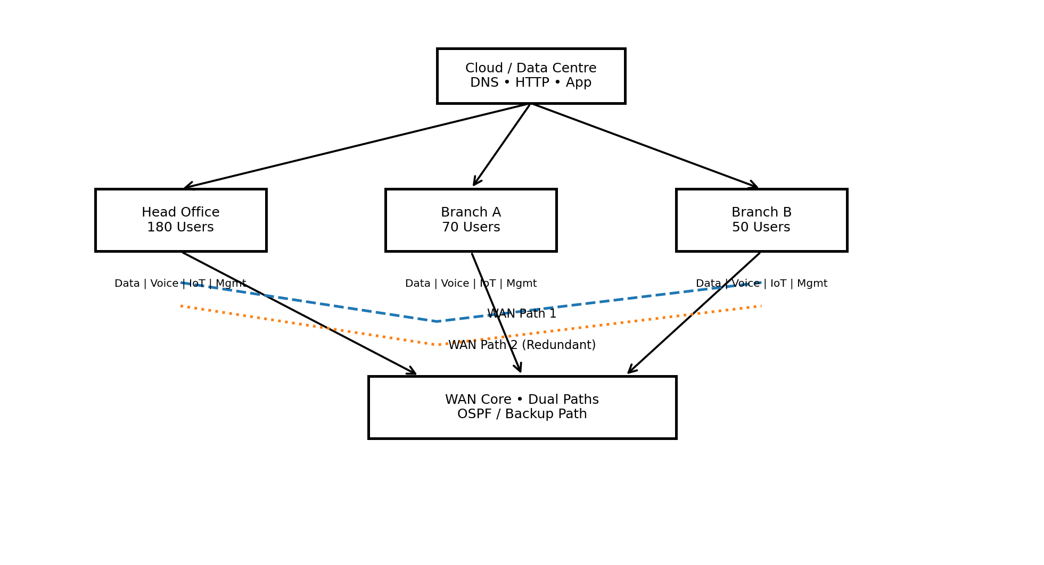
Figure 1: Proposed Logical Network Topology
Cloud/Data Centre: DNS Server, HTTP Server, Application Server → DC Router → WAN Network → HO Router / Branch A Router / Branch B Router. Each site router connects to local switches, which connect PCs, VoIP devices and IoT devices.

1.9 Network Segmentation
Each location is divided into User/Data, Voice, IoT and Management VLANs. The Data-Centre contains a Server VLAN and management network. Segmentation reduces broadcast traffic, improves security and permits different traffic classes to be managed independently.

1.10 Expected Failure Points
Expected failure points include WAN link failure, router failure, switch failure and server failure. The dual-WAN architecture is intended to maintain connectivity when one WAN path becomes unavailable.

1.11 Expected Performance Bottlenecks
Potential bottlenecks include limited WAN bandwidth, heavy video traffic, simultaneous VoIP calls, large data transfers, IoT traffic and congested router interfaces. WAN links are expected to be the most important bottleneck because they carry aggregated inter-site traffic.

2. Application of Course Knowledge

2.1 Network Topology
Routers provide WAN and inter-network connectivity, switches provide local connectivity, PCs provide user endpoints, IP phones support VoIP, IoT devices provide sensor/monitoring traffic, servers provide DNS/HTTP services, and redundant WAN links provide resilience.

2.2 IPv4 Subnetting and VLSM
A private IPv4 block such as 10.10.0.0/16 can be used. VLSM allocates subnet sizes according to actual requirements.

2.3 Address Allocation Table
Segment | Required Hosts | Network Address / CIDR | Usable Hosts
HO Data | 180 | 10.10.0.0/24 | 254
HO Voice | 60 | 10.10.1.0/26 | 62
HO IoT | 30 | 10.10.1.64/27 | 30
HO Management | 20 | 10.10.1.96/27 | 30
Branch A Data | 70 | 10.10.2.0/25 | 126
Branch A Voice | 30 | 10.10.2.128/27 | 30
Branch A IoT | 20 | 10.10.2.160/27 | 30
Branch A Management | 10 | 10.10.2.192/28 | 14
Branch B Data | 50 | 10.10.3.0/26 | 62
Branch B Voice | 20 | 10.10.3.64/27 | 30
Branch B IoT | 15 | 10.10.3.96/27 | 30
Branch B Management | 10 | 10.10.3.128/28 | 14
Data-Centre Servers | 20 | 10.10.4.0/27 | 30
WAN Point-to-Point Links | — | /30 subnets | 2 usable addresses each

2.4 Routing Protocol
OSPF is recommended as the primary routing protocol because it supports VLSM, dynamic route discovery, redundant paths, fast convergence and enterprise scalability.
Example configuration concept:
router ospf 1
network 10.10.0.0 0.0.255.255 area 0

2.5 Alternative Static Routing
A second design can use static routes with floating static routes for backup. The primary route is configured with a normal administrative distance and the backup route with a higher administrative distance. This provides a simple failover mechanism but becomes difficult to maintain as the network grows.

2.6 TCP and UDP Concepts
TCP provides connection-oriented, reliable, sequenced communication with acknowledgement and retransmission, making it suitable for HTTP, file transfer and business applications. UDP provides connectionless, low-overhead communication and is suitable for VoIP, real-time video and selected IoT applications where low latency is important.

2.7 Quality of Service
During congestion, traffic can be prioritized in the following order: VoIP, real-time video, DNS, business data and general background traffic. QoS can reduce the effect of congestion on delay-sensitive applications.

2.8 DNS and HTTP Services
The Data-Centre can contain a DNS server and HTTP server. Example mapping: www.retail.local → 10.10.4.10. Users can access the centralized application through http://www.retail.local.

3. Solution / Design / Methodology

3.1 Alternative A – OSPF with Dual WAN Links
Alternative A uses OSPF dynamic routing, two WAN paths, VLSM addressing, VLAN segmentation, dedicated IoT networks, QoS and centralized DNS/HTTP services. Under normal conditions, the preferred WAN path carries traffic. If it fails, OSPF detects the topology change and selects the alternate path.

3.2 Alternative B – Static Routing with Backup WAN
Alternative B uses static routes, floating static backup routes and dual WAN connections. It is simple and predictable, but has lower scalability, higher maintenance requirements and less flexibility when the network expands.

3.3 Configuration and Verification
Useful verification commands include:
show ip interface brief
show ip route
show ip ospf neighbor
show ip protocols
ping
tracert / traceroute
These tests verify interface status, routes, OSPF relationships and end-to-end connectivity.

3.4 Traffic Generation
Test normal data traffic between HO and branches, DNS/HTTP traffic between users and the Data-Centre, VoIP between sites, high-bandwidth video traffic, and mixed traffic consisting of data, DNS, HTTP, VoIP, video and IoT traffic.
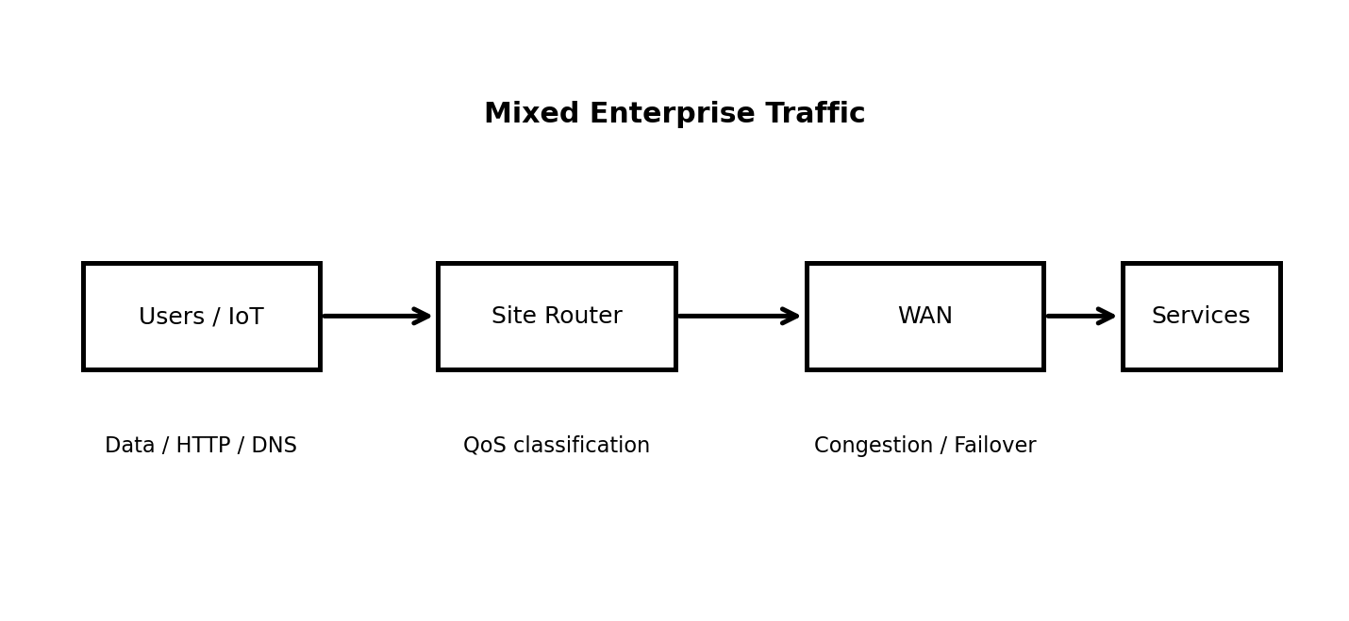
Figure 2: Enterprise Traffic Flow and Service Classification

3.5 Congestion Testing
Congestion is introduced by generating traffic that approaches or exceeds the WAN link capacity. Record throughput, delay, packet loss, link utilization and the effect on real-time services.

3.6 WAN Failure Testing
Disable the primary WAN link during a controlled test. Record the failure event, packet loss, route changes, recovery time/events and whether communication continues through the backup path.

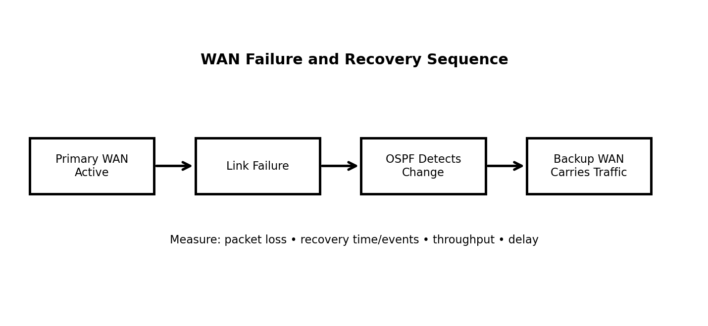
Figure 3: WAN Failure and Recovery Sequence

4. Use of Modern Tools

4.1 Primary Tool – Cisco Packet Tracer
Cisco Packet Tracer is suitable for router and switch configuration, IPv4 addressing, VLANs, OSPF, static routing, DHCP, DNS, HTTP, IP phones, IoT devices, simulation mode, packet analysis and failure testing.

4.2 Simulation Modes
Realtime Mode is used for configuration and normal connectivity verification. Simulation Mode is used to observe packet movement, protocol operation, packet drops, routing behaviour and recovery after failures.

4.3 Evidence to Submit
Include screenshots of the complete topology, IP configuration, router configuration, routing tables, OSPF neighbours, DNS/HTTP configuration, successful ping tests, failure events, recovery and simulation results. Submit the Packet Tracer/GNS3 project file and exported logs/results where applicable.

5. Results and Validation

5.1 Normal Network Test
With all WAN links operational, verify reachability between all sites and the Data-Centre. Measure throughput, average delay, packet loss and link utilization.

5.2 Congested Network Test
Generate high-volume data and video traffic. Expected effects include increased delay, increased packet loss, higher WAN utilization and reduced effective throughput. Proper QoS should reduce degradation of VoIP compared with background traffic.

5.3 WAN Failure Test
Disable one WAN path and observe connectivity, throughput, delay, packet loss and link utilization before, during and after recovery. The exact numerical results must be recorded from the simulation rather than assumed.
Recommended result figures to be populated from the Packet Tracer/GNS3 measurements:
Figure 5: Throughput under normal load vs congestion. [Insert simulation graph/data here.]
Figure 6: Average delay under normal load vs congestion. [Insert simulation graph/data here.]
Figure 7: Packet loss before, during and after WAN failure. [Insert simulation graph/data here.]
Figure 8: Link utilization and recovery behaviour. [Insert simulation graph/data here.]

5.4 Validation
Validate HO-to-Branch A, HO-to-Branch B, user-to-DNS, user-to-HTTP and inter-site application connectivity using ping, traceroute and application tests.

6. Analysis and Engineering Decision

6.1 Comparison of Alternatives
Alternative A: OSPF + Dual WAN — dynamic routing, high scalability, automatic route learning, strong resilience, medium configuration complexity, fast convergence and good enterprise suitability.

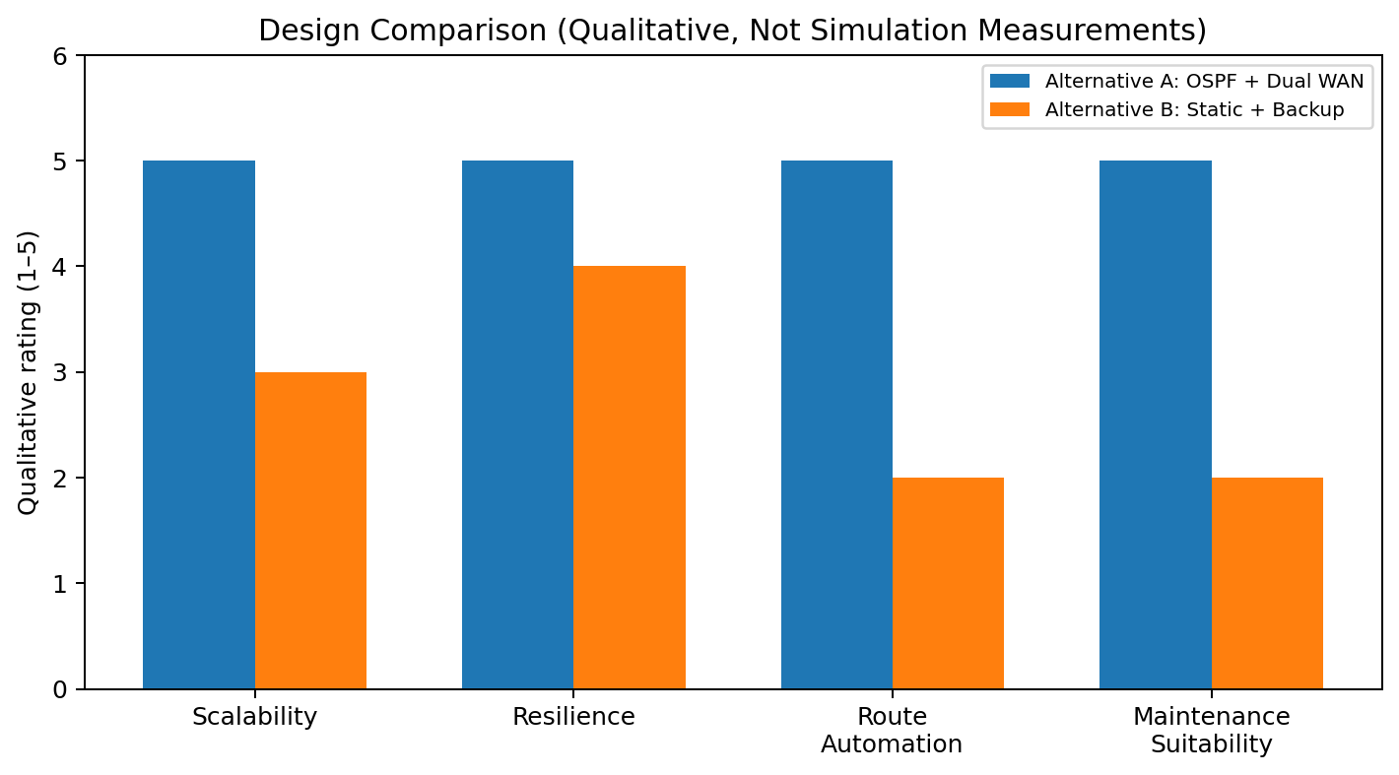
Figure 4: Qualitative Comparison of Alternative A and Alternative B (simulation values to be added)

6.2 Routing Efficiency
OSPF dynamically calculates paths based on link costs and can select another available path after failure. Static routing requires manually defined routes and therefore creates more administrative overhead.

6.3 Resilience and Convergence
The desired recovery sequence is: primary link failure → failure detection → routing table update → backup path selection → communication restoration. The actual recovery time/events should be measured from the simulation.

6.4 Scalability
The organization may add branches, users, IoT devices, servers and cloud applications. OSPF provides better scalability because routes can be dynamically learned.

6.5 Resource Usage
Static routing generally uses fewer router resources, while OSPF consumes additional CPU and memory for routing calculations. The operational benefits of dynamic routing become more valuable as network size and redundancy increase.

6.6 Recommended Design
Alternative A — OSPF with dual WAN links — is recommended because it provides stronger resilience, automatic routing adaptation, better scalability and easier long-term management. The final recommendation should be supported by measured simulation results showing throughput, delay, packet loss and recovery behaviour.

7. Broader Considerations

7.1 Reliability and Business Continuity
Network failure can interrupt business operations, branch communication, cloud applications, VoIP, video meetings and IoT monitoring. Redundant WAN connectivity improves business continuity.

7.2 Security Considerations
Use VLAN segmentation, ACLs, strong device passwords, SSH for secure management, restricted IoT access and firewall protection in production. Management traffic should be logically separated from user traffic.

7.3 IoT Security
IoT devices should be isolated and permitted to access only required services. ACLs, authentication and monitoring should be applied to reduce risk.

7.4 Scalability
Future improvements may include additional branches, IPv6, SD-WAN, cloud-based services, wireless LAN controllers and centralized network monitoring.

7.5 Energy and Resource Efficiency
Efficient subnetting, VLAN segmentation, routing, traffic prioritization and monitoring can reduce unnecessary traffic and improve infrastructure utilization.

7.6 Accessibility and Service Quality
QoS should protect voice and video communication during congestion so that voice remains understandable and video remains usable for users across locations.

8. Conclusion

8.1 Summary
The proposed enterprise network connects the Head Office, Branch A, Branch B and Cloud/Data-Centre using a resilient WAN architecture. IPv4 VLSM provides efficient addressing, while VLAN segmentation separates user, voice, IoT and management traffic. The network supports data, DNS, HTTP, VoIP, video and IoT services.

8.2 Final Decision
OSPF with dual WAN links is preferred over static routing with backup because it provides dynamic route discovery, better scalability and automatic adaptation to WAN failures. The decision should be validated using simulation measurements.

8.3 Limitations and Improvements
Packet Tracer cannot reproduce every characteristic of a real enterprise network, particularly exact physical-layer and real-world WAN behaviour. A production deployment could be improved with redundant routers, firewalls, advanced QoS, IPv6, SD-WAN, monitoring and stronger security controls.

9. Student Reflection

9.1 Learning Outcome
This industry problem improves understanding of IPv4 subnetting, VLSM, VLANs, routing, redundancy, TCP/UDP behaviour and QoS in a practical enterprise environment.

9.2 Unexpected Behaviour
The congestion experiment demonstrates that high-bandwidth video and mixed traffic can increase delay and packet loss, while the WAN failure experiment demonstrates the importance of redundant connectivity combined with an appropriate routing mechanism.

9.3 Future Improvements
With additional time, tools and budget, the project could be extended using GNS3 or a larger-scale simulator, realistic traffic patterns, advanced QoS, firewall/ACL security, IPv6 and SD-WAN evaluation.

10. References

10.1 Recommended References
1. Behrouz A. Forouzan, Data Communications and Networking, McGraw-Hill.
2. Andrew S. Tanenbaum and David W. Wetherall, Computer Networks, Pearson.
3. James F. Kurose and Keith W. Ross, Computer Networking: A Top-Down Approach, Pearson.
4. Cisco Networking Academy, Cisco Packet Tracer documentation and learning resources.
5. Cisco Systems, OSPF configuration and routing documentation.
6. RFC 2328, OSPF Version 2.
7. RFC 791, Internet Protocol Version 4 (IPv4).
8. RFC 768, User Datagram Protocol (UDP).
9. RFC 793, Transmission Control Protocol (TCP).
10. Relevant Cisco Packet Tracer documentation and simulation resources.

Common Assessment Rubric

Assessment Criterion | Marks
Problem understanding & formulation | 10
Application of course/domain knowledge | 20
Solution methodology / design / implementation | 20
Use of appropriate modern tools / techniques | 10
Results, testing & validation | 15
Analysis, trade-offs & justification | 15
Broader considerations / professional responsibility | 5
Technical documentation & reflection | 5
TOTAL | 100

CO–PO–Assessment Mapping

Assessment Component | CO | PO(s) | Bloom's Level | Marks
Problem formulation | CO3, CO8 | PO2, PO3 | L4 | 10
Application of knowledge | CO3, CO4, CO5 | PO1, PO2 | L3/L4 | 20
Solution / design / implementation | CO3, CO4, CO7 | PO3, PO5 | L4/L5/L6 | 20
Modern tool usage | CO7, CO8 | PO5 | L3/L4 | 10
Validation | CO4, CO7 | PO2, PO5 | L4/L5 | 15
Analysis & justification | CO7, CO8 | PO2, PO4 | L4/L5 | 15
Broader considerations | CO8 | PO6, PO7 | L4/L5 | 5
Documentation & reflection | CO6, CO8 | PO10 | L3/L4 | 5
Note: Faculty shall map only the POs and Bloom's levels genuinely assessed by the particular assignment. Every assignment is not required to map to every PO.

Faculty Evaluation & Continuous Improvement CO Attainment

Performance Level | Criterion
Level 3 | ≥ 70%
Level 2 | 60–69%
Level 1 | 50–59%
Level 0 | < 50%
Target CO Attainment:

Actual CO Attainment:

Faculty Analysis
Areas in which students performed well: Areas requiring improvement:
Corrective / Improvement Action:
Action to be implemented in the next offering:
Documents to be Maintained
The department/course faculty shall maintain:
- Assignment question/problem statement
- CO–PO and Bloom's mapping
- Assessment rubric
- Student submissions
- Tool/simulation/experimental evidence, where applicable
- Evaluated scripts/reports
- Marks and rubric-wise assessment
- CO attainment analysis
- Sample student work representing different performance levels
- Faculty analysis and continuous-improvement action

